- \Operation\Basic settings\Speed
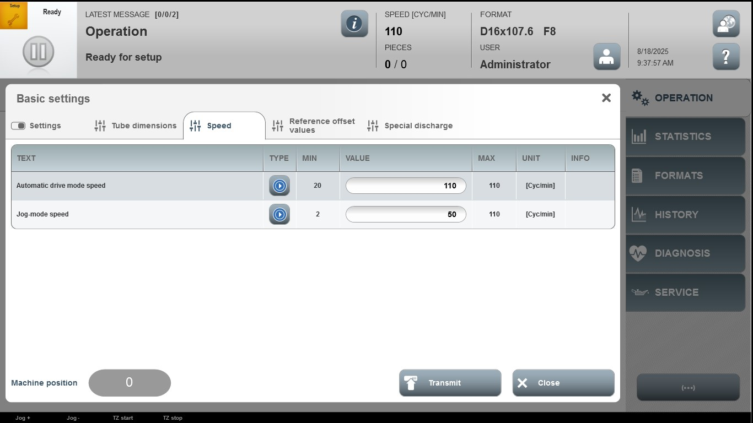

Acceptance criterion | Limits | Pass / Fail: Dev-No. | Date | Initials
Screen matches screenshot | N / A
Automatic drive mode speed | 20…110
Jog-mode speed | 2…110

